**Web Scraping**

Analystt.ai

Mar 2023

J Jeevan Roy

Dept. of Aerospace Engg.

IIT Madras

**Website**: Amazon

**Product**: Backpack

**1.1 Product Rating and Reviews**

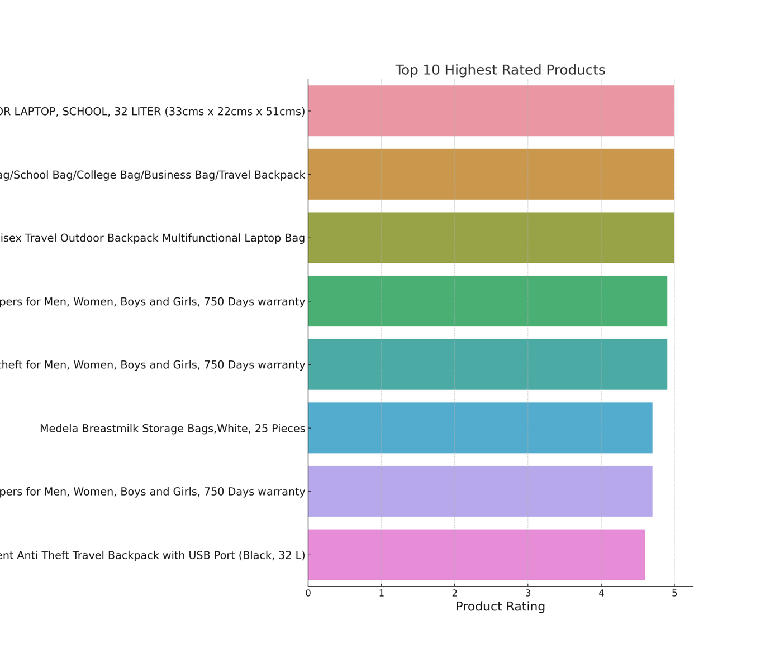

**Insight**: These are the top 10 products with the highest ratings. The probability of customer satisfaction with the variants of the 10 products is high.

**Action**: Businesses could analyze to understand what features and quality make these products exceptional and include them in their own products.

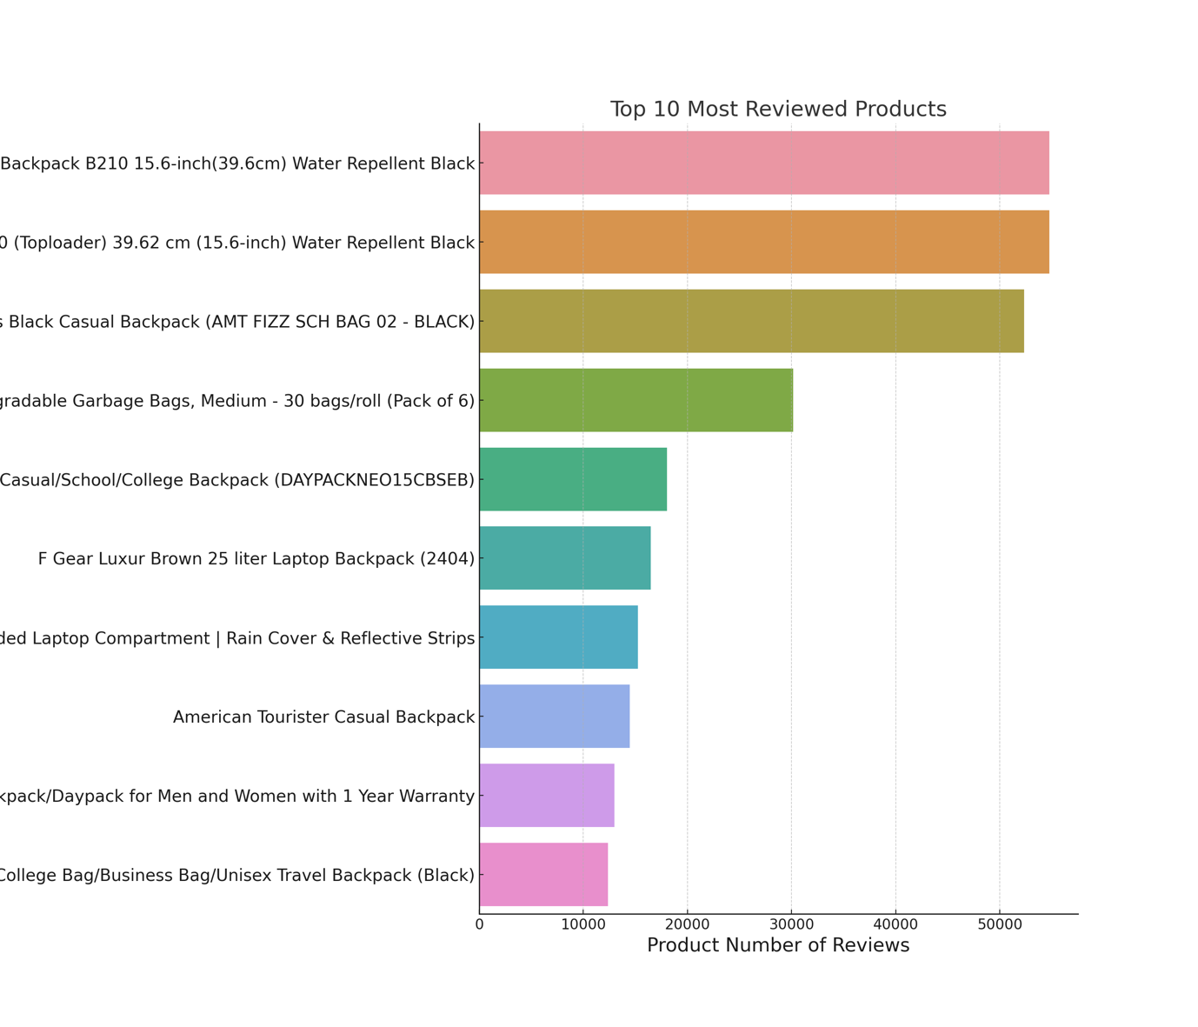

**Insight**: Some products have an exceptionally high number of reviews.

**Action**: Businesses should study these products to understand what makes the users buy and give a review on them, i.e., popular and try to implement similar features or marketing strategies.

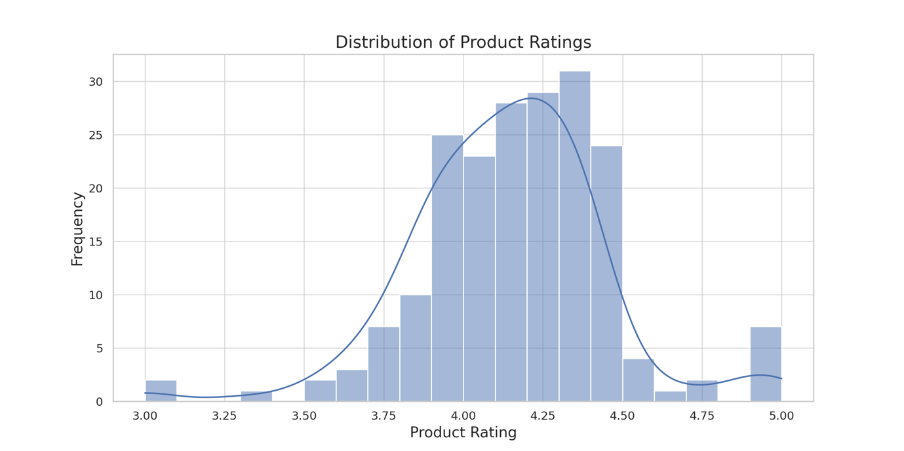

**Insight:** Most products have ratings between 4 and 4.5, i.e., products are well-received.

**Action:** Businesses should maintain or improve the quality of the products to fall the rating in this range.

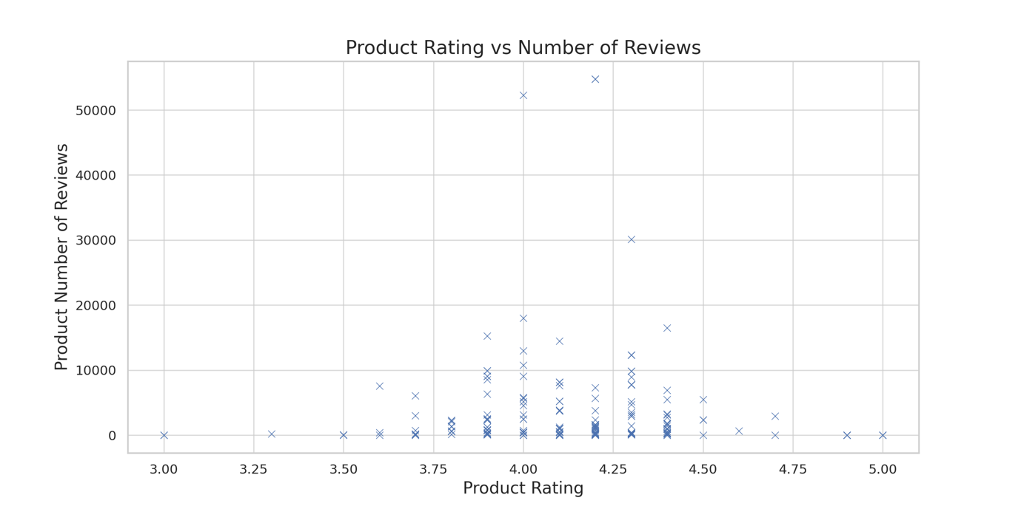

**Insight**: Products with a rating of 4 to 4.5 have the highest number of reviews.

**Action**: Businesses could focus on this rating range to receive more product reviews, which makes the product popular, thereby improving market reputation.

**1.2 Product Prices**

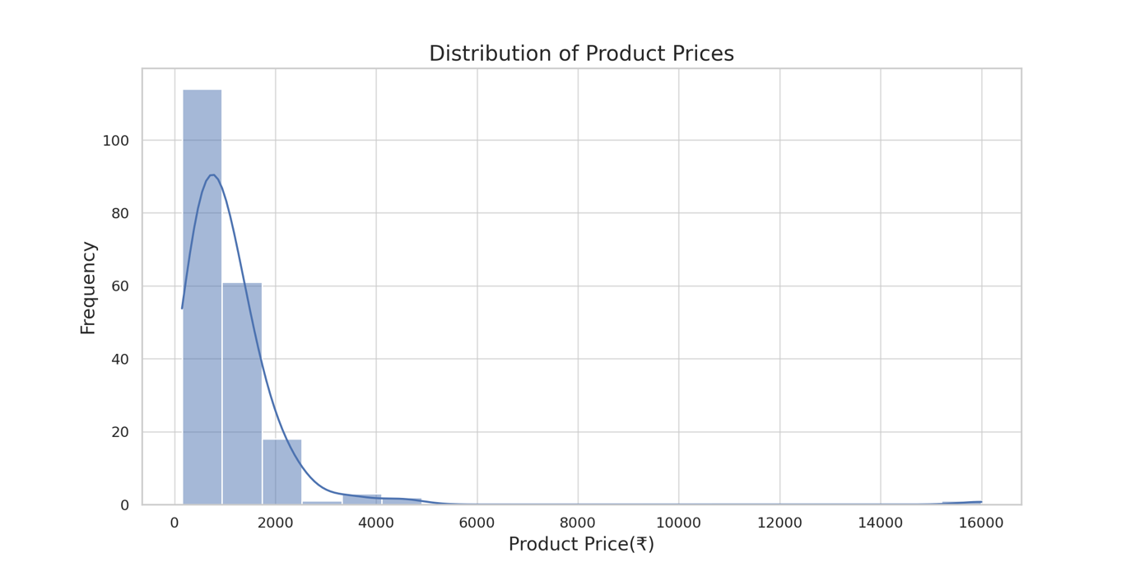

**Insight**: Most products are available at a price below ₹2000.

**Action**: Businesses could focus on this price range while making their own products.

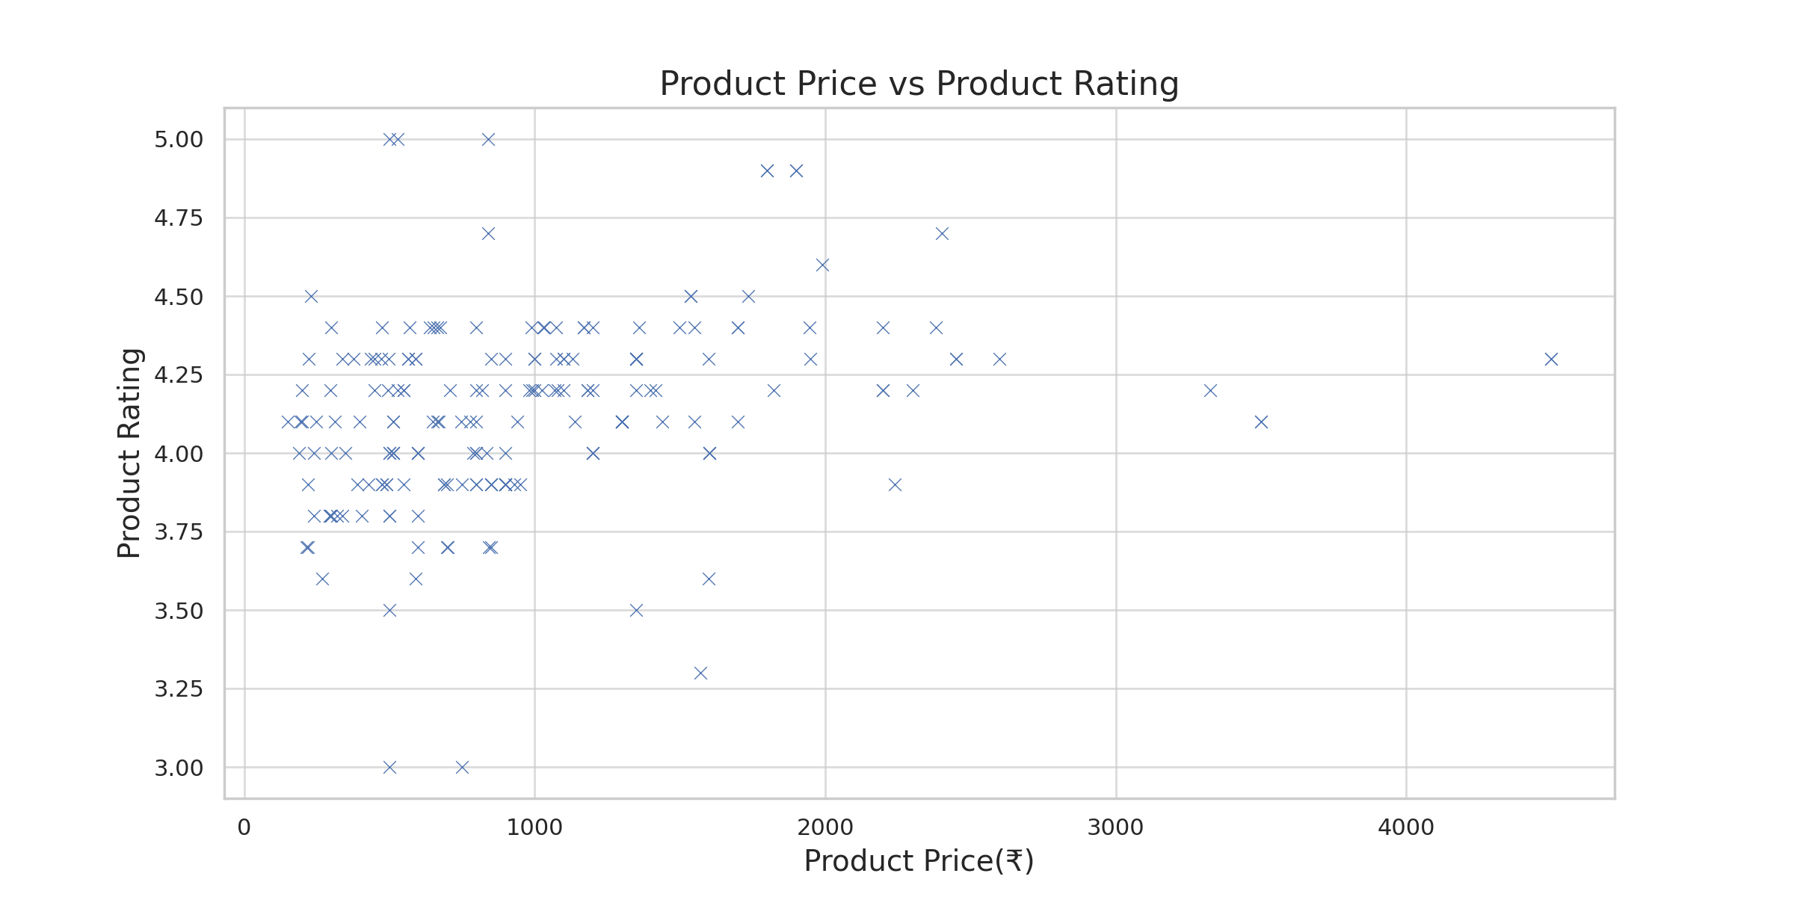

**Insight**: Most products with high ratings are priced below ₹2000. Customers prefer affordability.

**Action**: Businesses should focus and make products in this price range to attract customers and receive better reviews. Put emphasis on budget-friendly products.

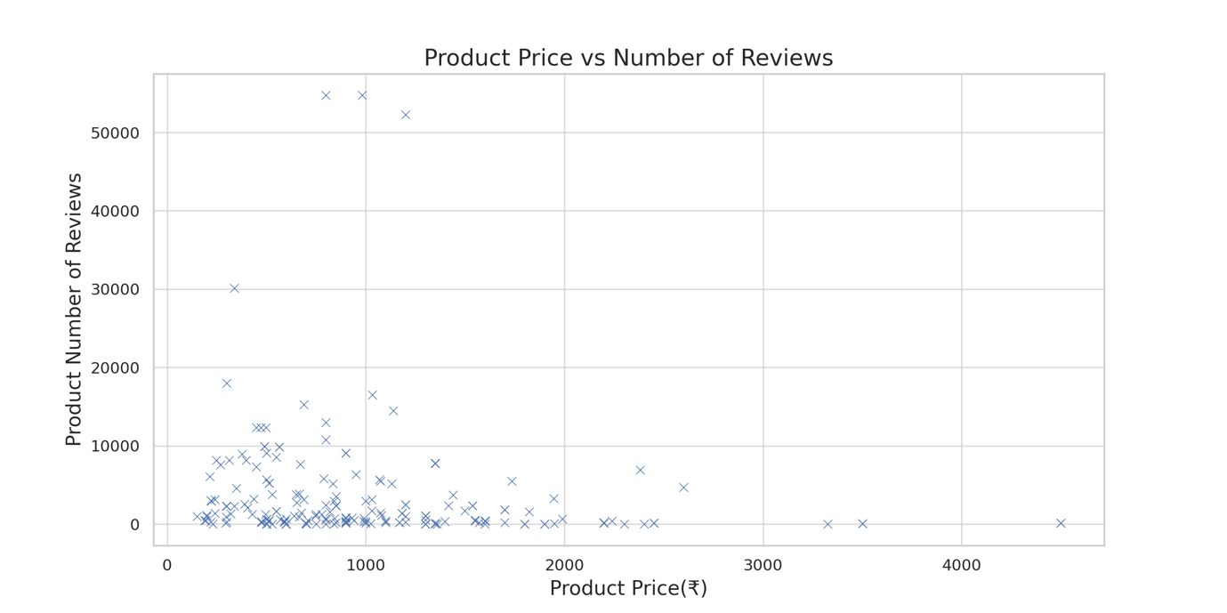

**Insight**: Products with a price of less than ₹2000 have more reviews

**Action**: Businesses should focus on products at this price range to maximize customer engagement and reviews. This is strongly recommended as this conclusion came twice.

***